Participant Name: Krithik Gokul S
SmartCrowd AI: Intelligent Crowd Management System for Sporting Venues

📄 Abstract
SmartCrowd AI is a cloud-based system that improves crowd movement, reduces waiting time, and provides real-time updates in large venues. It uses Google Cloud Run and Docker for scalable and efficient performance.

❗ Problem Statement
Large venues face overcrowding, long queues, and poor coordination. There is a need for a smart system to manage crowd flow, reduce delays, and improve safety using real-time data.

⚙️ Existing System
- Manual crowd control
- Static signboards
- No real-time updates
- High waiting time

🚀 Proposed System
- Real-time crowd tracking
- Smart navigation (low crowd routes)
- Queue prediction
- Cloud-based system using Google Cloud Platform

💻 Coding Part (Google Cloud)

🏟️ SmartCrowd AI – Full Setup Guide

⚙️ STEP 0: Prerequisites (VERY IMPORTANT)
Install these tools:
- Python (3.8 or above)
- Docker
- Google Cloud SDK
👉 Also create a project in
- Google Cloud Platform

📁 STEP 1: Create Project Folder
mkdir smartcrowd
cd smartcrowd

📄 STEP 2: Create Files
Create 3 files inside the folder:

🔹 app.py
from flask import Flask, jsonify, request
import random
app = Flask(__name__)
zones = {
"Gate A": 50,
"Food Court": 80,
"Restroom": 30
}
@app.route("/")
def home():
return "SmartCrowd AI Running!"
@app.route("/crowd")
def crowd():
return jsonify(zones)
@app.route("/predict")
def predict():
zone = request.args.get("zone")
return jsonify({
"zone": zone,
"predicted_crowd": random.randint(10, 120)
})
if __name__ == "__main__":
app.run(host="0.0.0.0", port=8080)

🔹 requirements.txt
flask
gunicorn

🔹 Dockerfile
FROM python:3.10-slim
WORKDIR /app
COPY . /app
RUN pip install -r requirements.txt
CMD exec gunicorn --bind :$PORT app:app

▶️ STEP 3: Run Application Locally (Without Docker)

Install dependencies
pip install -r requirements.txt

Run app
python app.py

Open in browser
http://localhost:8080

Test APIs
http://localhost:8080/crowd
http://localhost:8080/predict?zone=Gate A

🐳 STEP 4: Build Docker Image
docker build -t smartcrowd .

▶️ STEP 5: Run Docker Container
docker run -p 8080:8080 smartcrowd
👉 Open:
http://localhost:8080

☁️ STEP 6: Login to Google Cloud
gcloud auth login

⚙️ STEP 7: Set Project ID
gcloud config set project promptwarsproject-492814

🔌 STEP 8: Enable Required APIs
gcloud services enable run.googleapis.com
gcloud services enable cloudbuild.googleapis.com

📦 STEP 9: Build & Push Image to Cloud
gcloud builds submit --tag gcr.io/promptwarsproject-492814/smartcrowd

🚀 STEP 10: Deploy to Cloud Run
gcloud run deploy smartcrowd \
--image gcr.io/promptwarsproject-492814/smartcrowd \
--platform managed \
--region asia-south1 \
--allow-unauthenticated

🌐 STEP 11: Get Live URL
After deployment, you will get:
https://smartcrowd-145365073250.asia-south1.run.app/

🧪 STEP 12: Test Live Application
Open in browser:
https://smartcrowd-145365073250.asia-south1.run.app/predict?zone=Food Court
https://smartcrowd-145365073250.asia-south1.run.app/crowd
https://smartcrowd-145365073250.asia-south1.run.app/predict?zone=Gate A

Snapshot of Prototype

📸 Snapshot of Prototype
----------------------------
| SmartCrowd Dashboard |
----------------------------
| Gate A : High Crowd |
| Food Court : Medium |
| Exit Gate : Low |
----------------------------
| Suggested Route → Gate B |
----------------------------

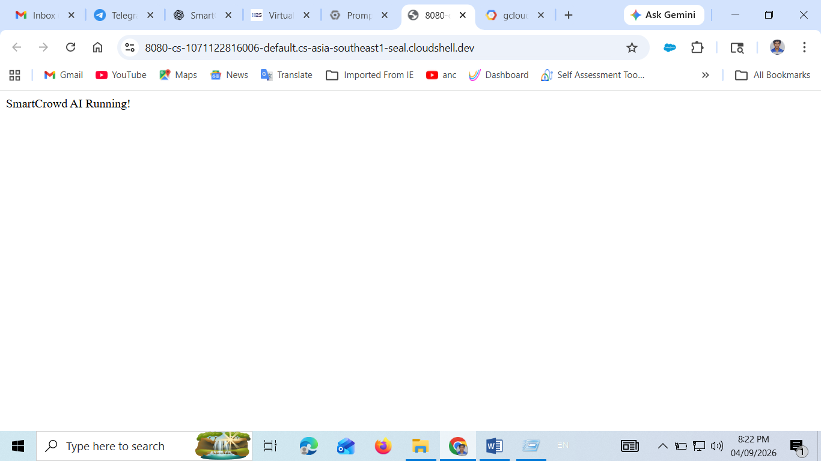
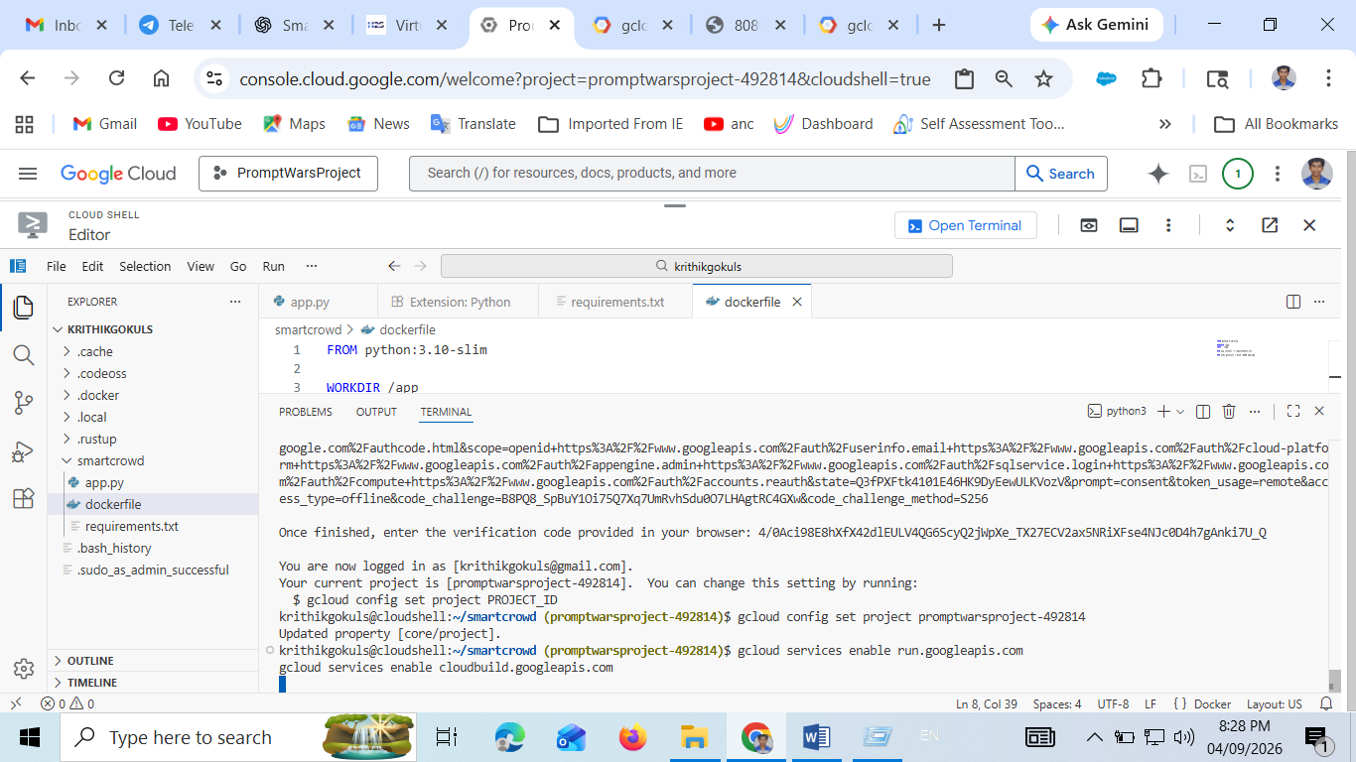
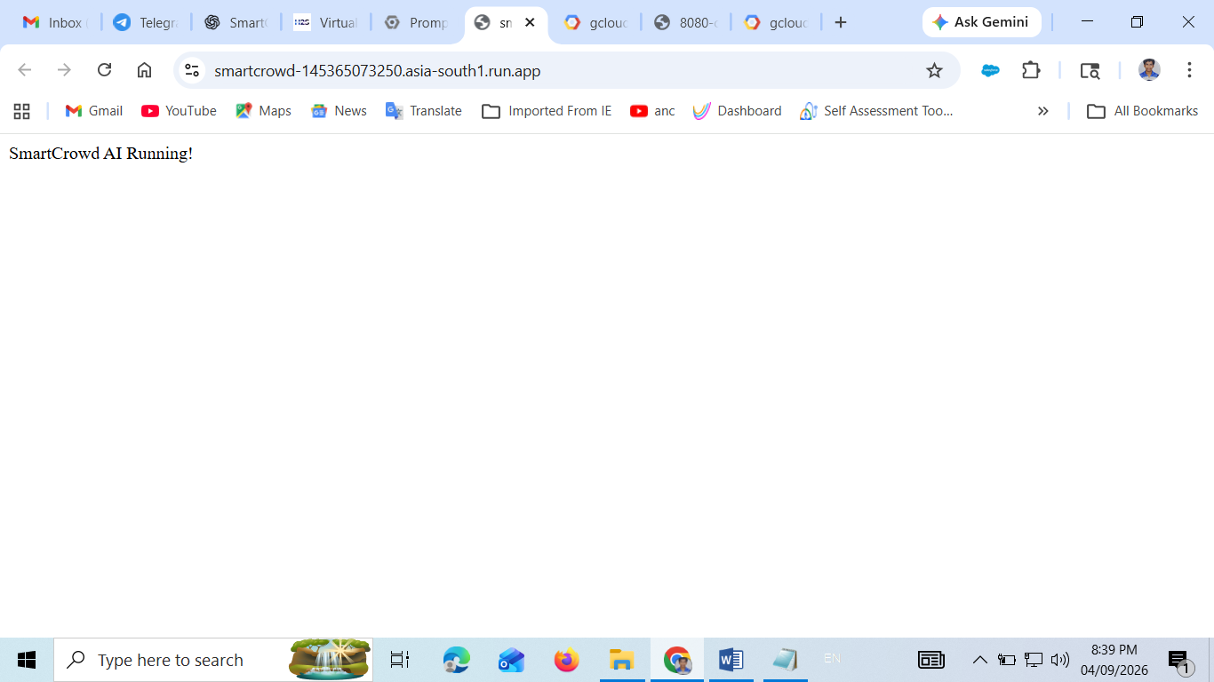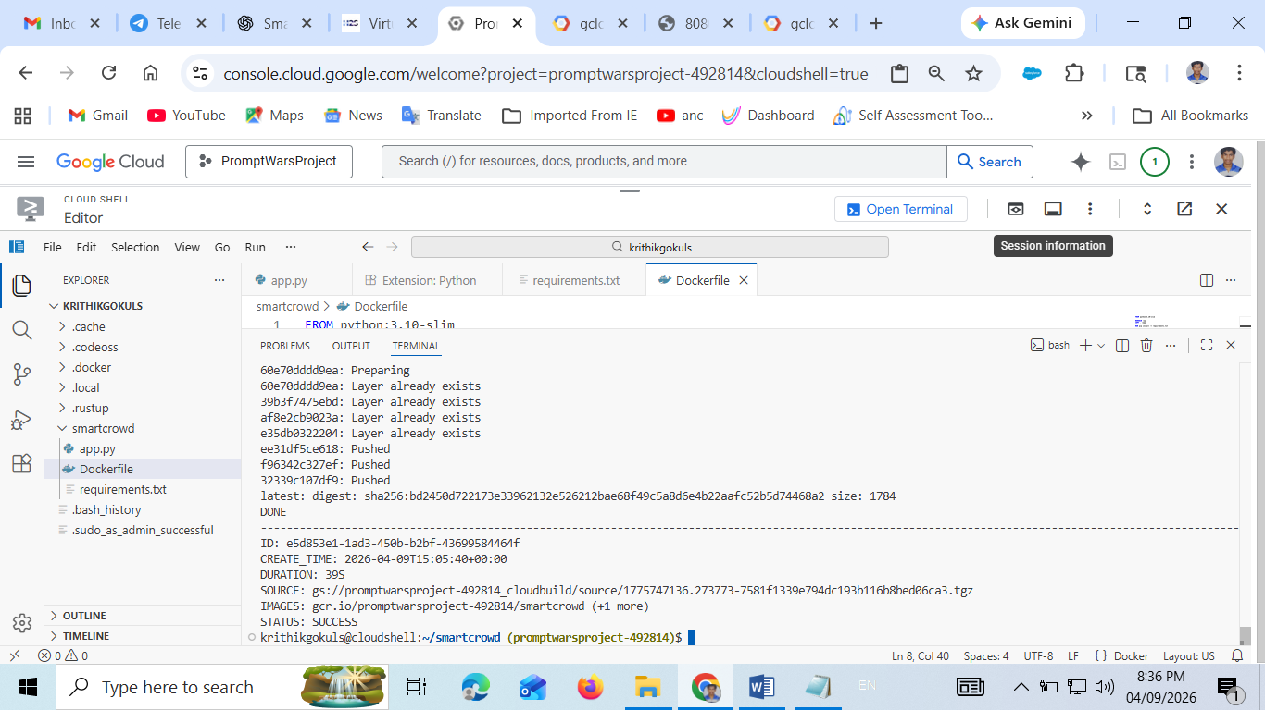
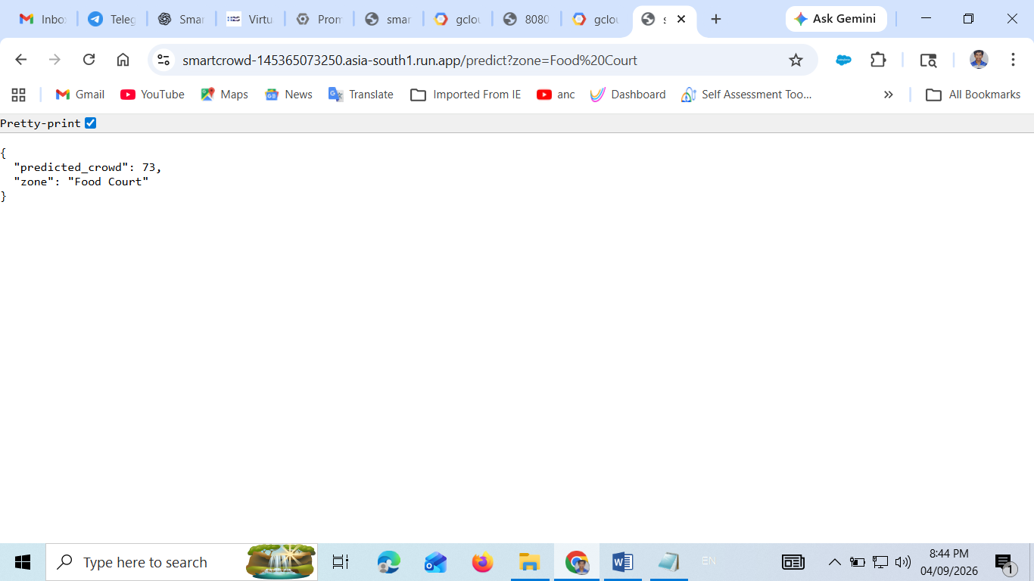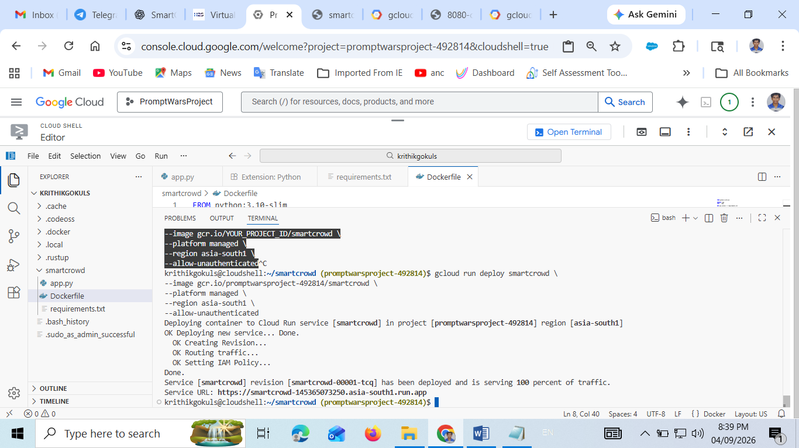
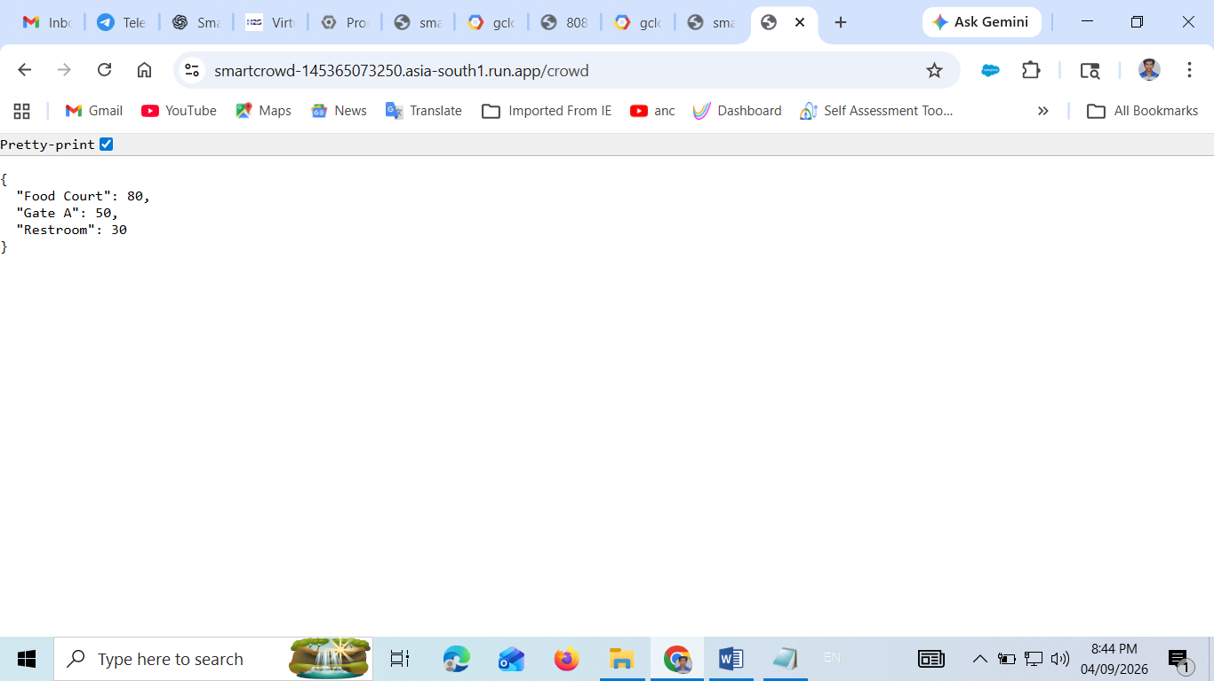
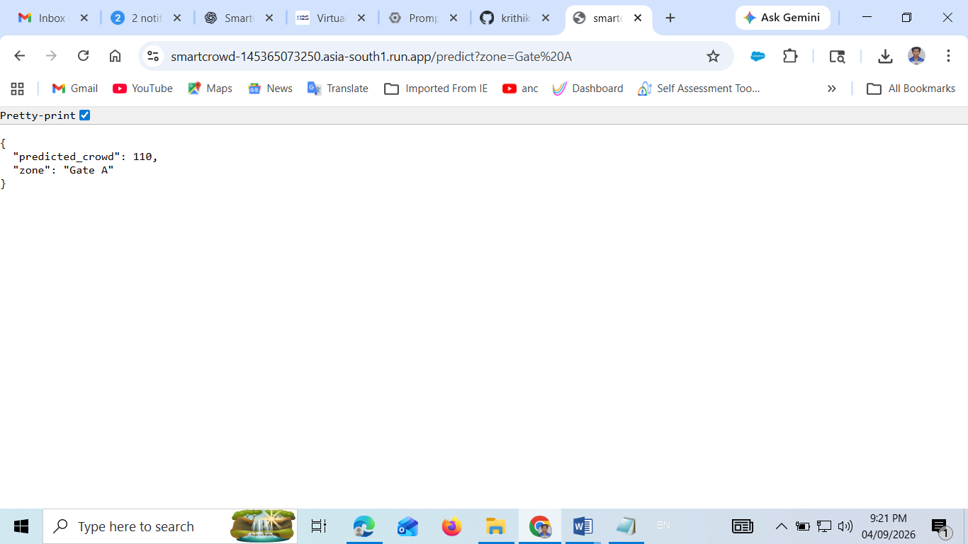

✅ Advantages
- Real-time monitoring
- Reduced waiting time
- Better safety
- Scalable cloud system

🌍 Applications
- Stadiums
- Concerts
- Airports
- Shopping malls

🔮 Future Scope
- AI-based prediction
- AR navigation
- Emergency alerts system

🏁 Conclusion
SmartCrowd AI improves event experience by reducing congestion and providing real-time insights using cloud technology.

📚 References
- Google Cloud Documentation
- Flask Documentation
- IoT Research Papers

